Open Source Audit Project Report
Student Name: Tuhinsh Sharma
Roll Number: 24BCE10559
Course: Open Source Software – NGMC
Unit Coverage: 1–5
Date of Submission: 23 March 2026
GitHub Repository: https://github.com/24-Tuhinsh/oss-audit-24BCE10559

1. Introduction

What is Open-Source Software?

Open-source software is defined as the type of software whose source code is free for modification and redistribution. In contrast to proprietary software, the focus of open-source is transparency and freedom.

The Linux operating system is a prime example of open-source software. This operating system was developed by Linus Torvalds in 1991.

Purpose of the Project:

• To understand the concept of open-source by using the Linux operating system.

• To explore the file system structure and permissions.

• To develop shell scripts to automate the auditing process.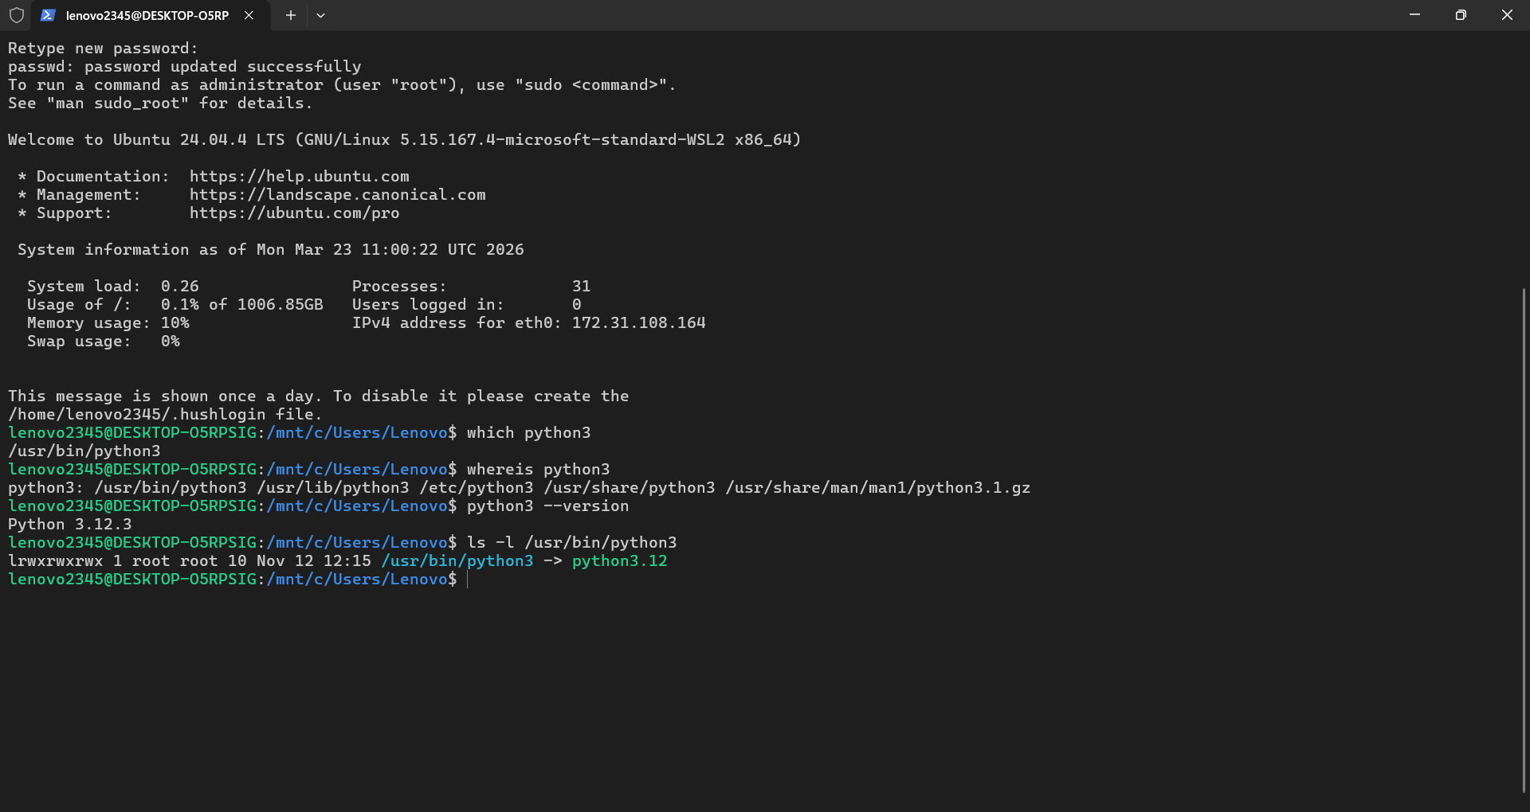

2. Selected Software
Software: Linux Operating System
Category: Operating System
License: GPL v2
Reasons for choice:
1. Linux is completely open-source software. This makes it suitable for auditing.
2. Linux supports a variety of software tools.
3. Linux offers a great environment for shell scripting.
4. Linux is used in the industry.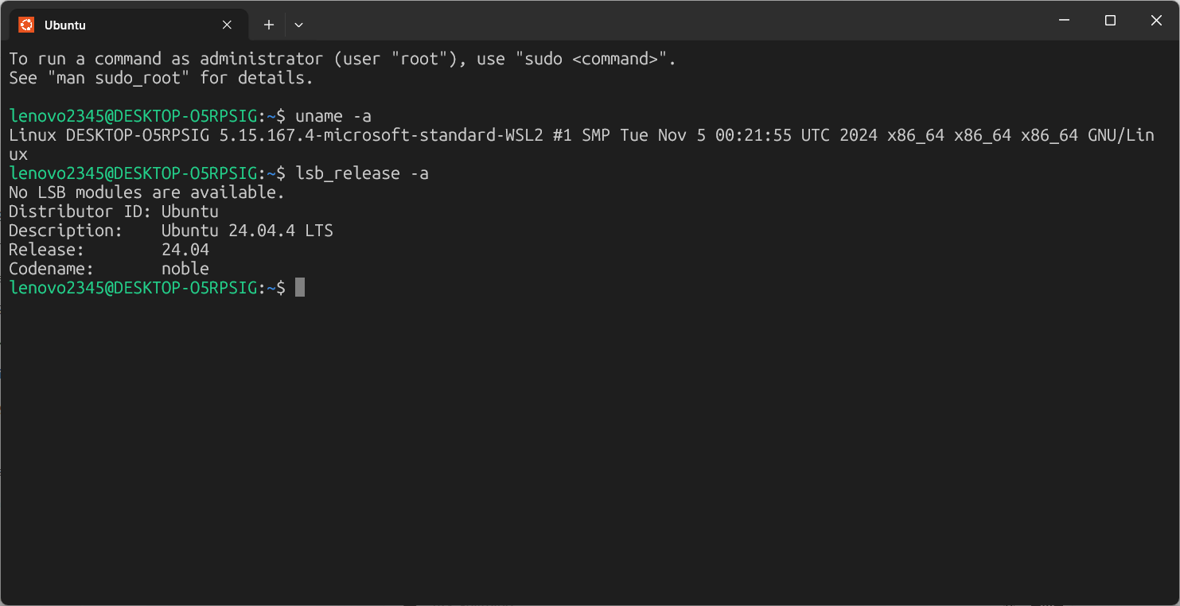

Part A – Origin and Philosophy
A1. The Problem it Solves
• The proprietary system, like Unix or Windows, was expensive and restricted in the 1990s.
• Linux solves the cost and restriction problems related to learning and innovating.
• It gives power to the student, the programmer, and the small business.
________________________________________
A2. License Details
Linux is free and open-source software, which means that it follows the GPL v2 license. The GPL v2 gives the user:
1. Freedom to run the software for any purpose.
2. Freedom to study and modify the source code.
3. Freedom to share the original and modified software.
4. The obligation to use the same license when sharing the software.
Examples:
• Red Hat offers the software for a fee, but they send the fixes back.
• The user must offer the modified software under the GPL v2.
A3. Ethics and Open Source
• Some software should not be open source; some software should have proprietary licenses.
• Some software should have the open source license.
• The Linux system is an example of ethical software.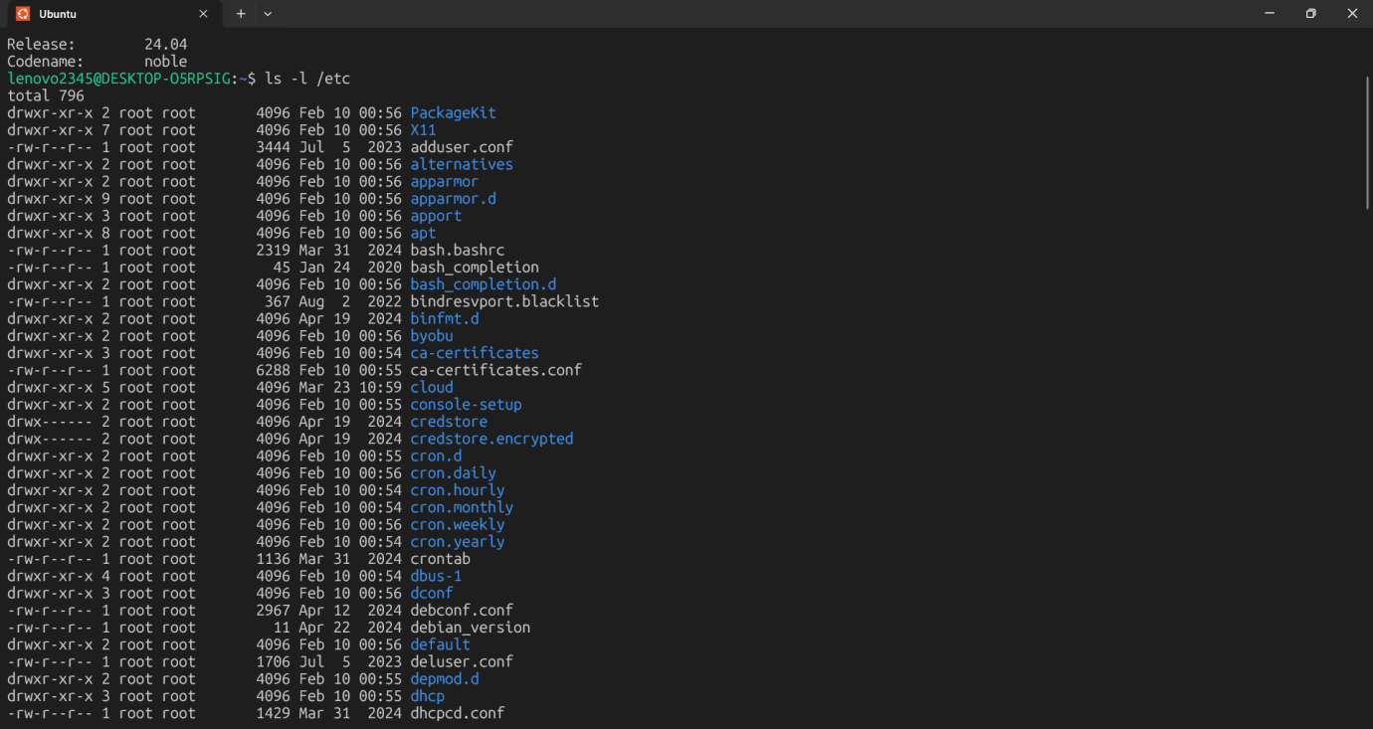
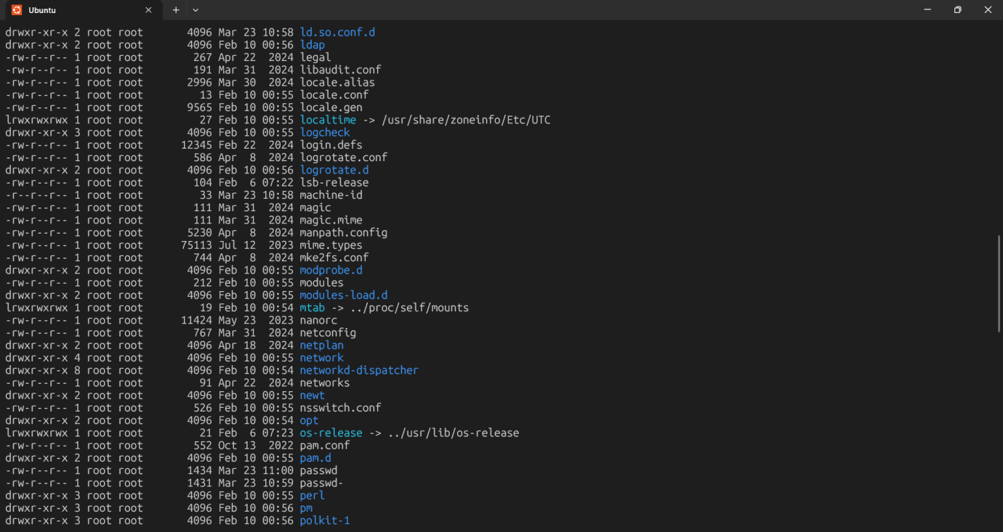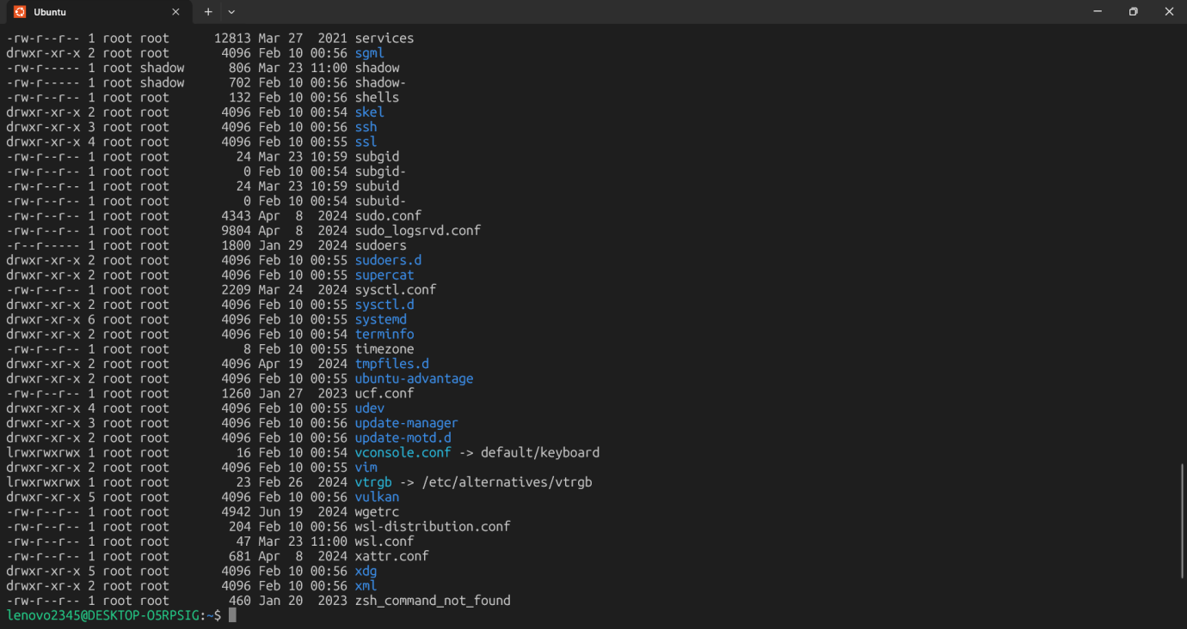
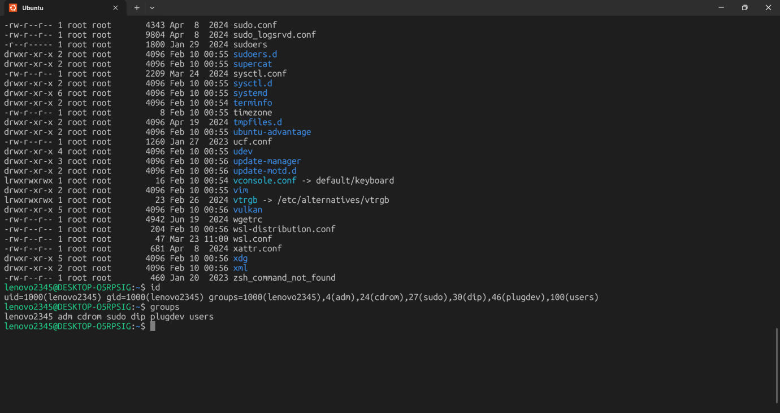

Part B – Linux Footprint
B1. Installation
• Installed on WSL (Windows Subsystem for Linux).
• Alternative installations: Ubuntu ISO, Fedora, or Debian on physical machines.
B2. Directory Structure
Directory Purpose
/etc Configuration files
/usr/bin Executable binaries
/home User data
/var/log System logs
________________________________________
B3. Users and Groups
• Root user: full administrative privileges.
• Regular user: limited access for safety.
• Commands: whoami, groups, id.
________________________________________
B4. Services and Processes
• systemctl start/stop/restart [service]
• Logs stored in /var/log can be analyzed via grep and tail.
B5. Updates and Package Management
• Ubuntu/Debian uses apt.
• Examples: apt list --installed, dpkg -l. 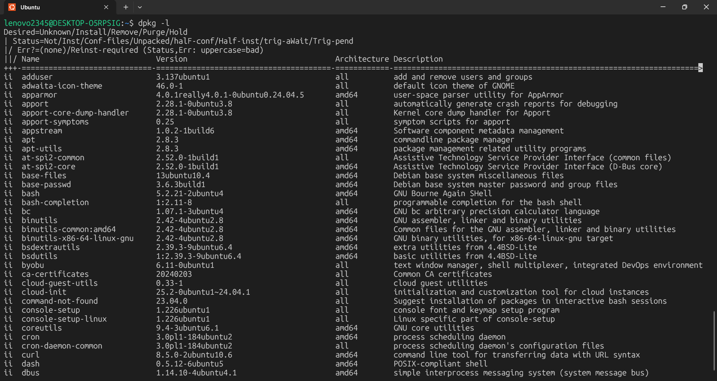
5. Part C – Open Source Ecosystem
• Linux kernel maintained by Linus Torvalds and Linux Foundation.
• Supported by GNU tools, bash, glibc.
• Linux distributions - Ubuntu, Fedora, Debian, Arch.
• Popular open-source applications - Git, Docker, Kubernetes, Apache, MySQL.
Community & Collaboration:
• Mailing lists, forums, GitHub repositories.
• Collaborative development encourages forking, pull requests, code reviews.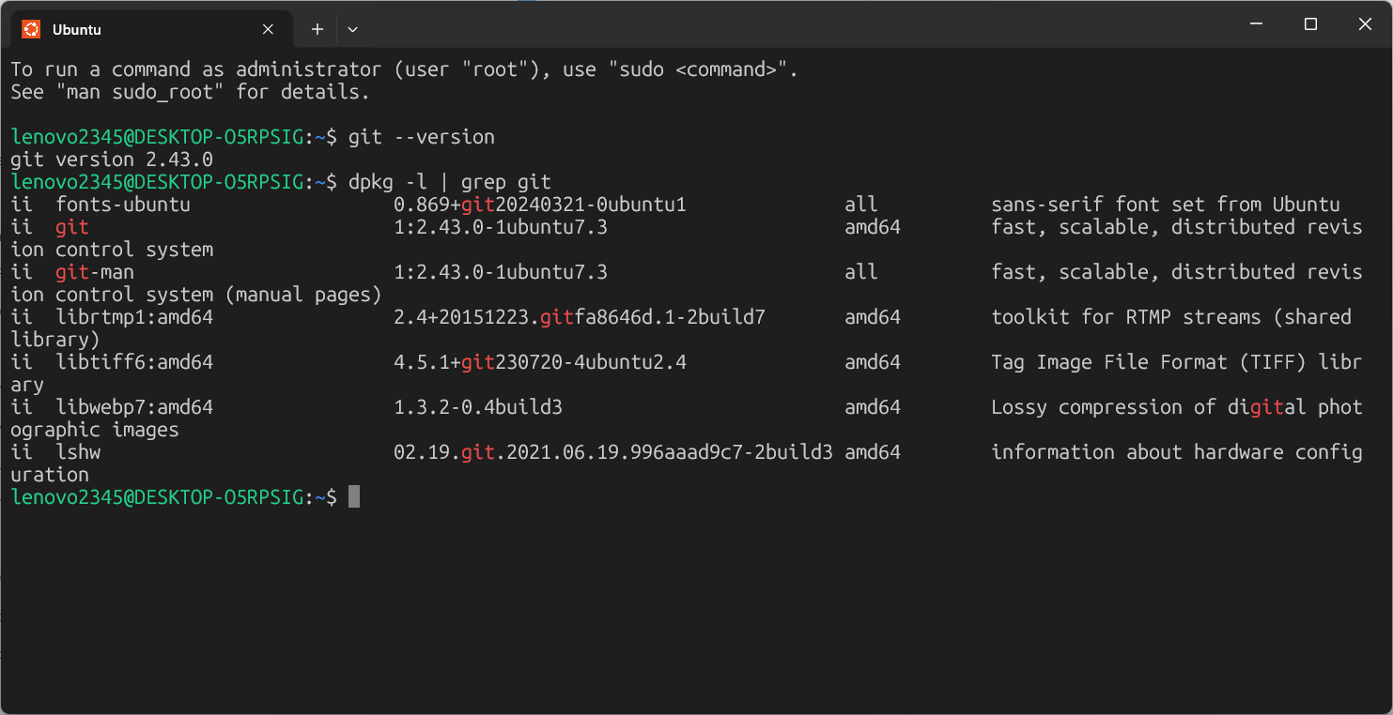
6. Part D – Comparison: Open Source vs Proprietary
Feature Linux (OSS) Windows (Proprietary)
Cost Free Paid
Security Auditable Closed source
Customization Full Limited
Control User/community Vendor
Updates Community-driven Vendor-driven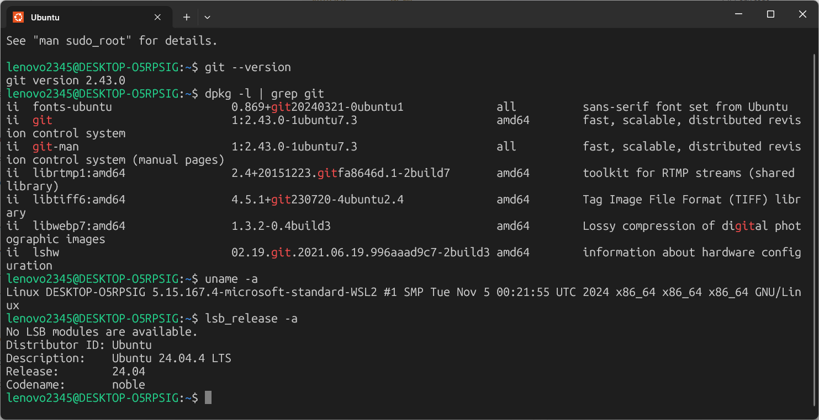

7. Part E – Shell Scripts

Script 1 – System Identity Report
- Purpose: Show hostname, OS version, uptime, and logged-in users.
- Concepts Used: Variables, command substitution, echo.
- Screenshot: Terminal output after running ./script1.sh.

Script 2 – FOSS Package Inspector
- Purpose: Check installed packages, versions, and dependencies.
- Concepts Used: if-then, case, loops, package management commands.
- Screenshot: Terminal output of ./script2.sh.

Script 3 – Disk and Permission Auditor
- Purpose: Audit disk usage and directory permissions.
- Concepts Used: for loops, ls -l, df -h, awk.
- Screenshot: Output showing directories and permissions.

Script 4 – Log File Analyzer
- Purpose: Count keyword occurrences in system logs and show last entries.
- Concepts Used: while-read loop, grep, counters.
- Screenshot: Output of ./script4.sh /var/log/syslog error.

Script 5 – Open Source Manifesto Generator
- Purpose: Generate a personal open-source philosophy.
- Concepts Used: read input, string concatenation, file write.
- Screenshot: Output file content manifesto_<username>.txt.

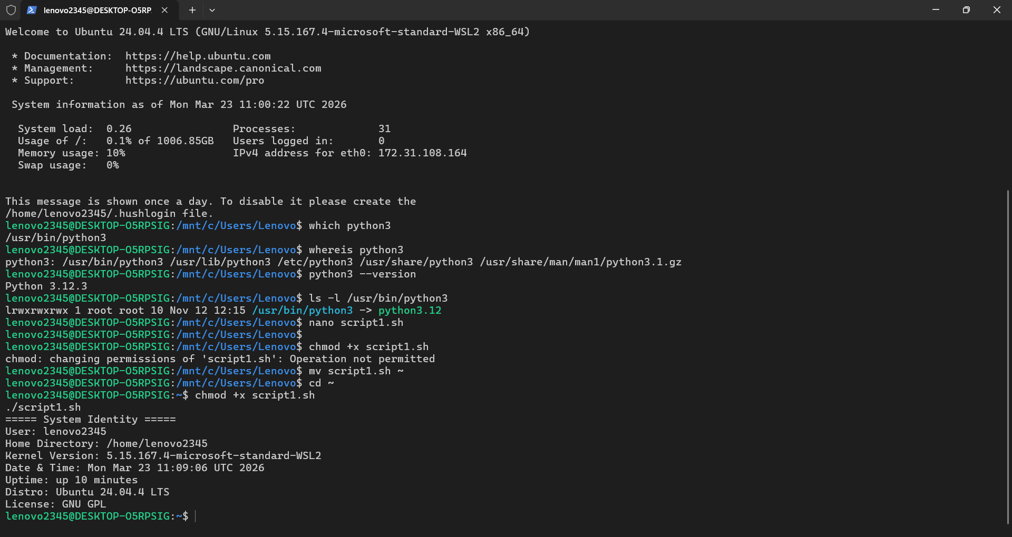

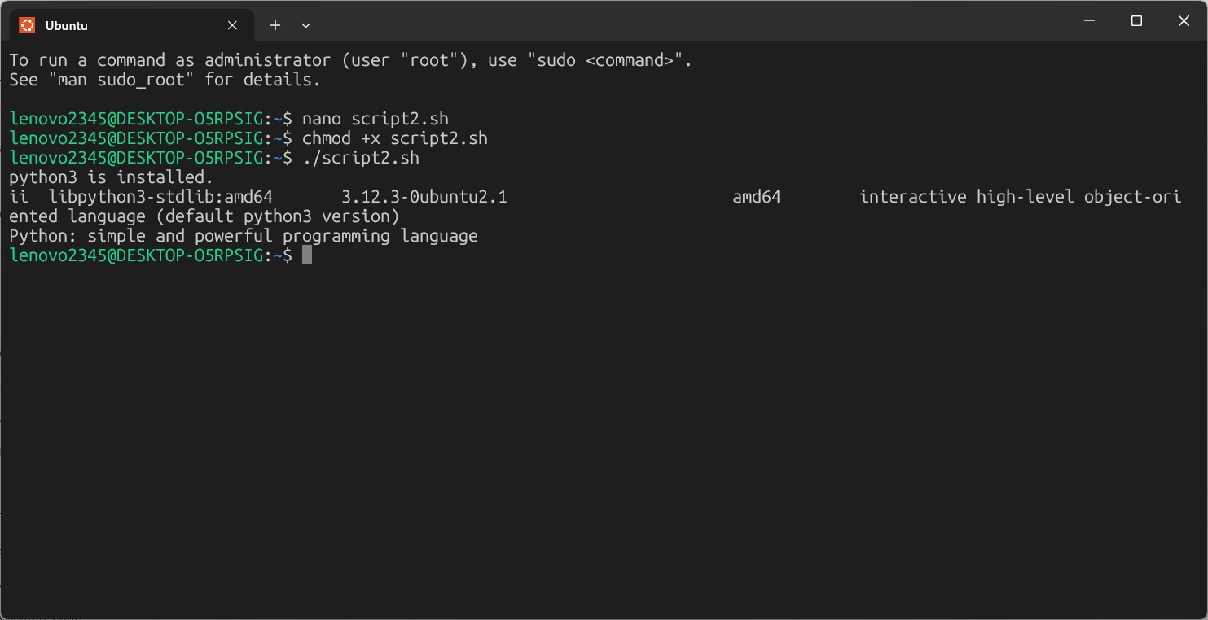

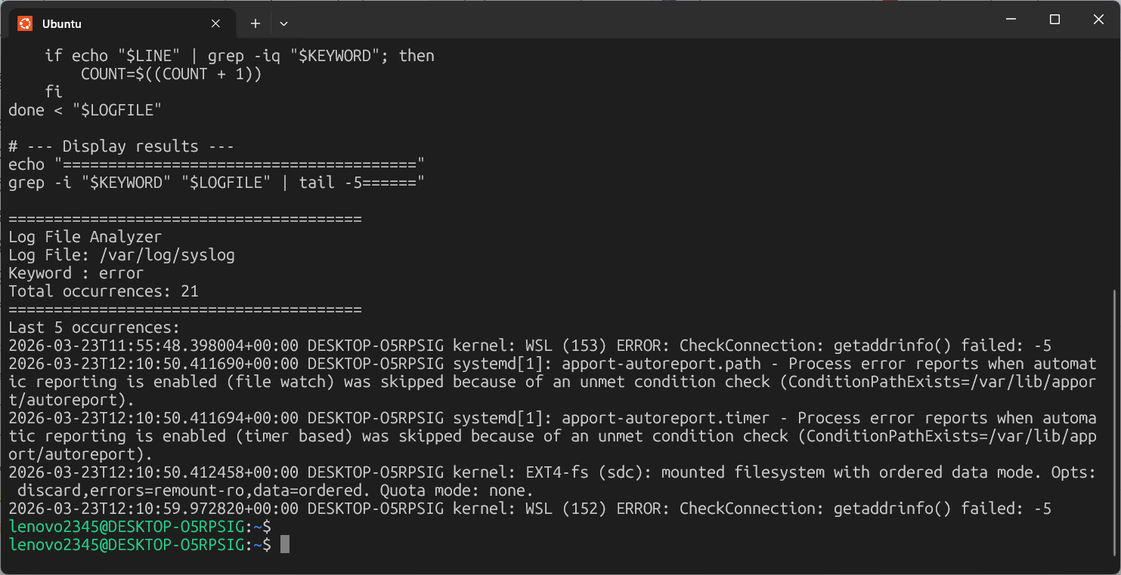

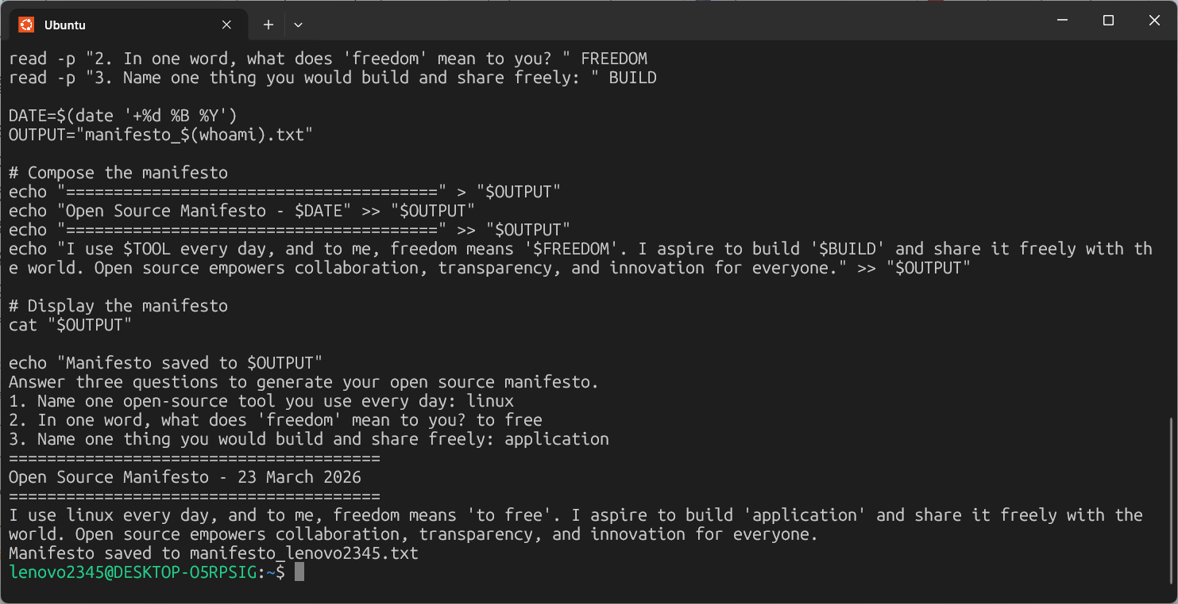
9. Conclusion
1• Linux is a strong open-source operating system that reflects the concepts of freedom, collaboration, and ethics within a community.
- • The audit scripts are a demonstration of knowledge of Linux.
- • OSS concepts are important for developers, students, and businesses to make ethical and efficient decisions regarding software.
- • OSS projects promote "learning by doing" and collaboration across the world.
10. References
1. GNU Project – Free Software Definition: https://www.gnu.org/philosophy/free-sw.html
2. Open Source Initiative – Open Source Definition: https://opensource.org/osd
3. Linux Kernel Documentation: https://www.kernel.org/doc/html/latest/
4. Bash Scripting Reference: https://www.gnu.org/software/bash/manual/

